**DAILY ONLINE ACTIVITIES SUMMARY**

|  |  |  |  |  |  |  |  |  |
| --- | --- | --- | --- | --- | --- | --- | --- | --- |
| **Date:** | **29/05/2020** | | | | | **Name:** | **PONICA.J** | |
| **Sem & Sec** | **4TH & B** | | | | | **USN:** | **4AL18CSO55** | |
| **Online Test Summary** | | | | | | | | |
| **Subject** | | **OPERATING SYSTEMS** | | | | | | |
| **Max. Marks** | | **30** | | **Score** | | | **27** | |
| **Certification Course Summary** | | | | | | | | |
| **Course** | **MACHINE LEARNING** | | | | | | | |
| **Certificate Provider** | | | **BRAIN O VISION** | | **Duration** | | | **3 DAYS** |
| **Coding Challenges** | | | | | | | | |
| **Problem Statement:1.C PROGRAM ON ARMSTRONG**  **2.JAVA PROGRAM FOR LARGEST PLUS FORMED AND BINARY MATRIX** | | | | | | | | |
| **Status:EXECUTED** | | | | | | | | |
| **Uploaded the report in Github** | | | | | **YES** | | | |
| **If yes Repository name** | | | | | **https://github.com/ponica-jaya/LOCKDOWN-CODING.git** | | | |
| **Uploaded the report in slack** | | | | | **YES** | | | |

Online Test Details: (Attach the snapshot and briefly write the report for the same)

Today (29/05/2020)I had test on the subject operating systems from 9.00 am to 9.45am which had 30 mcq questions to be answered and each carried one mark.The below is the snapshot of my results

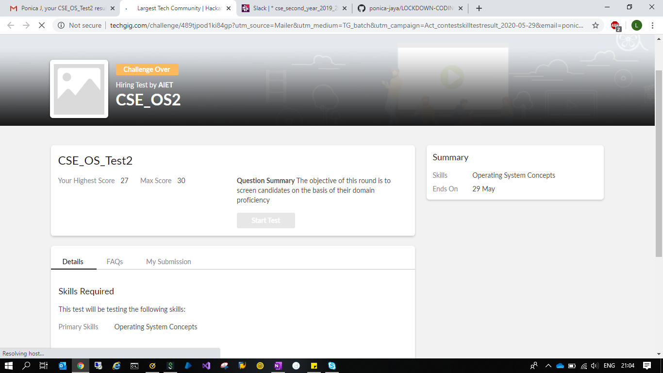

Certification Course Details: (Attach the snapshot and briefly write the report for the same)

Today I have attended certification course on machine learning which is of 3days and today is the last day of the course.Due to technical issues it was conducted at 6.00pm on youtube.The below is the snapshot of my certification course

Coding Challenges Details: (Attach the snapshot and briefly write the report for the same)

Daily our lecturers mail coding programs problems .But today I have tried to solve 3 of the programs which is c and java.So finally I have done and executed and uploaded to github account.The below is the snapshot of today’s program.

